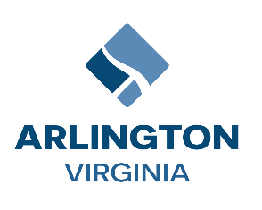

**Audit Committee Meeting**

Thursday, December 12, 2024/ 4:30 pm – 6:30 pm

Conference Room 311 (Ellen Bozman Government Center)

2100 Clarendon Blvd., Arlington, VA 22201

**Virtual:** [**Join** **the meeting now**](https://teams.microsoft.com/l/meetup-join/19%3ameeting_ZmQwZTVkNzMtNTgyYy00MTI5LTg1N2YtNGM0MmExMmQwOTk3%40thread.v2/0?context=%7b%22Tid%22%3a%2280354804-1fdf-428e-9f5f-5091e994cf54%22%2c%22Oid%22%3a%2238dee129-1cf4-4868-ac5b-926b92dd2d47%22%7d)

**AGENDA**

1. Call to Order

*Action Items:*

1. Approval of September 26, 2024, Meeting Minutes (Co-Chairs)*Information – Presentation – Discussion:*
2. Co-Chairs Report (Takis Karantonis and Maureen Coffey)
3. Status Update - Office of County Auditor FY 2025 Work Plan (Wayne Scott)
4. Miscellaneous Items – Committee Members
5. Adjournment